Thomas Patten

Python

Demonstration and application of skills

Table of Contents

Checking for Palindromes 2

Scope 2

Coding and Test 2

Flowchart 3

Pseudocode 4

QA python loop task 5

Scope 5

Coding and Test 5

Flowchart 5

Pseudocode 6

Green bottle nursery rhyme 7

Scope: 7

Coding and Test 7

Flowchart 7

Pseudocode 8

Basic calculator 8

Scope 8

Coding and Testing 8

Flowchart 10

Pseudocode 10

# Checking for Palindromes

## Scope

Write a program that checks if a string entered by the user is a palindrome. A palindrome is a word that reads the same forwards as backwards like “racecar”

## Coding and Test

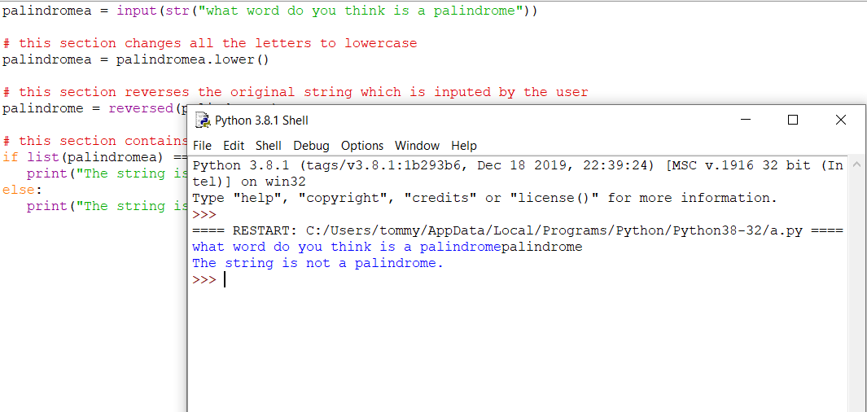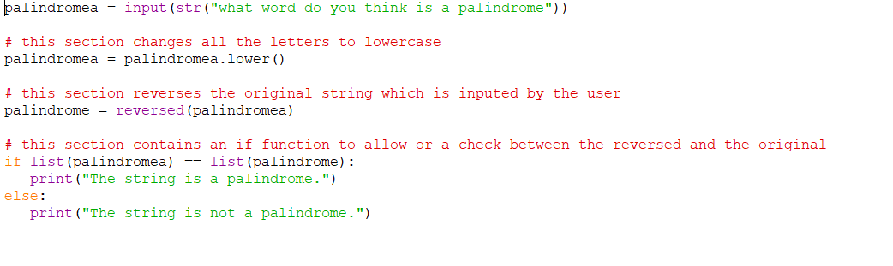

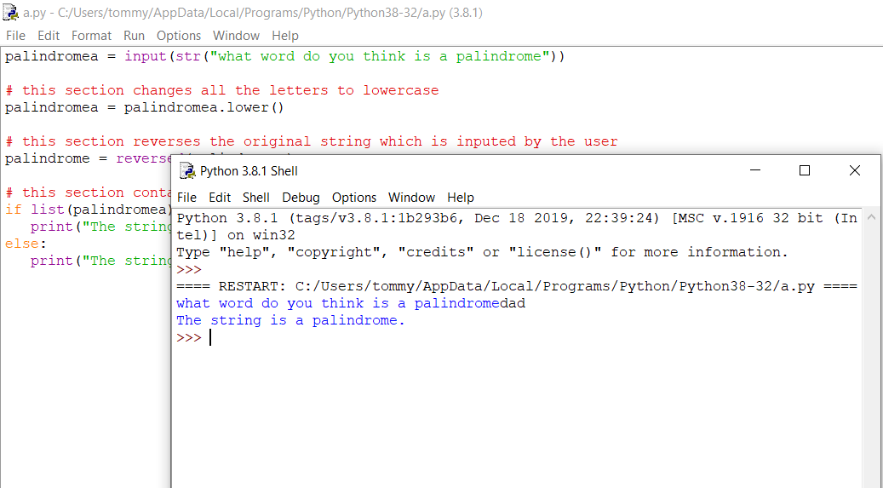

## Flowchart

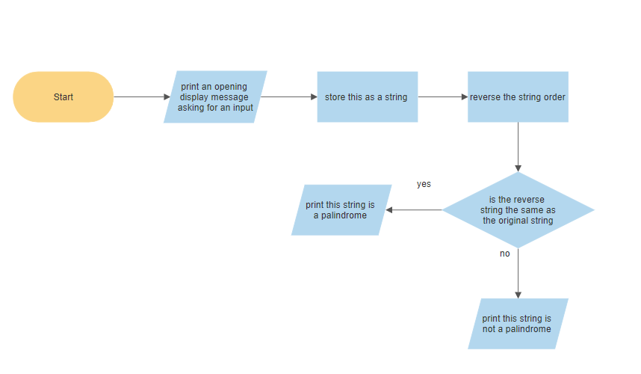

end

## Pseudocode

Print what word do you think is a palindrome

Take the input and store as a string

Change Palindromea case to lower

Reverse palindromea and store as a

Checks palindromea against palindrome

If they match

Print the string is a palindrome

Else

Print this string is not a palindrome

# QA python loop task

## Scope

To create a program in which the user will input the maximum range on numbers they want the square too, also whilst terminating the program if the preset limit of 200 is reached.

## Coding and Test

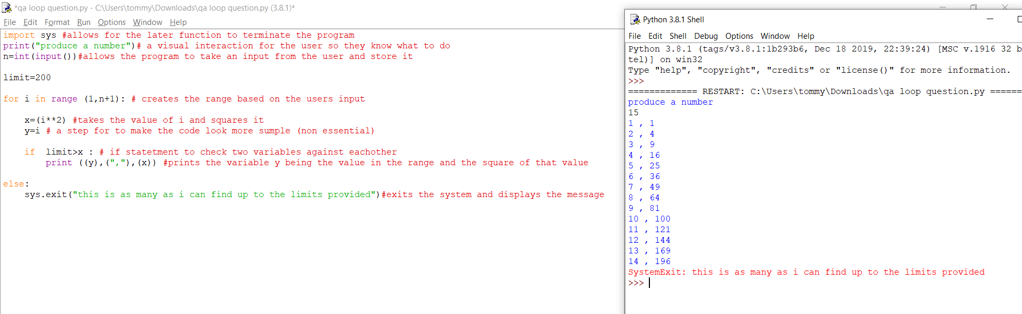

## Flowchart

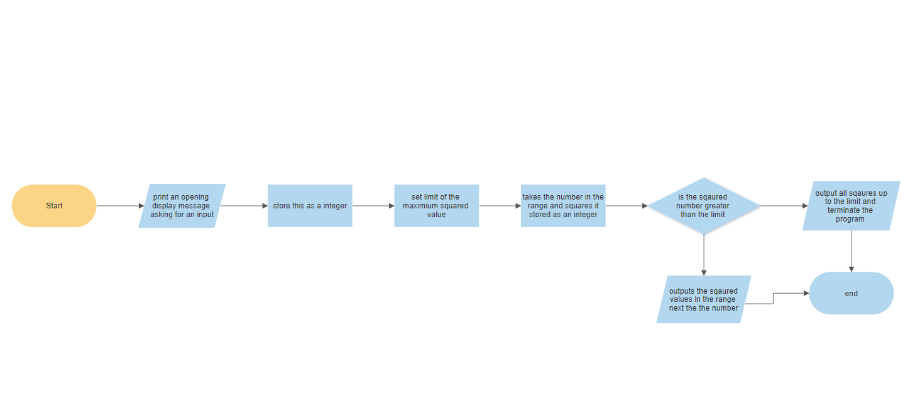

## Pseudocode

print produce a number

take input and store as an integer

set limit = 200

for I in range 1, n+1

x= I ^2

y=I

if limit >x

print y, x

else

exit program /print

# Green bottle nursery rhyme

## Scope:

Sing Along:

Create a program that prints the lyrics to the song ‘10 green bottles’ in as few lines of code as possible. Extension:

* Develop this program so that you can enter any starting number and it will count down from there.

## Coding and Test

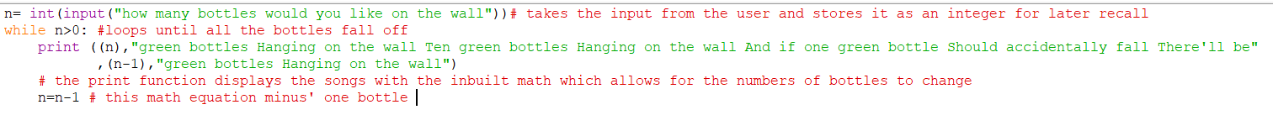

## Flowchart

## Pseudocode

Print how many bottles are on the wall

Takes an input and stores it as an integer

While the integer is less than 0

Print n, green bottles Hanging on the wall Ten green bottles Hanging on the wall and if one green bottle Should accidentally fall There'll be, n-1, green bottles Hanging on the wall

N=N-1

# Basic calculator

## Scope

To create a basic calculator which multiplies divides subtracts and adds specified numbers together.

Extension

* Allows the user to input two numbers and a function
* Writes the answer to a file for later keeping
* Add a power function

## Coding and Testing

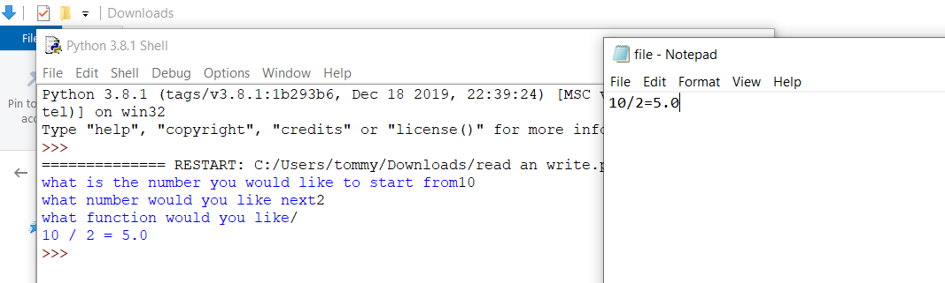

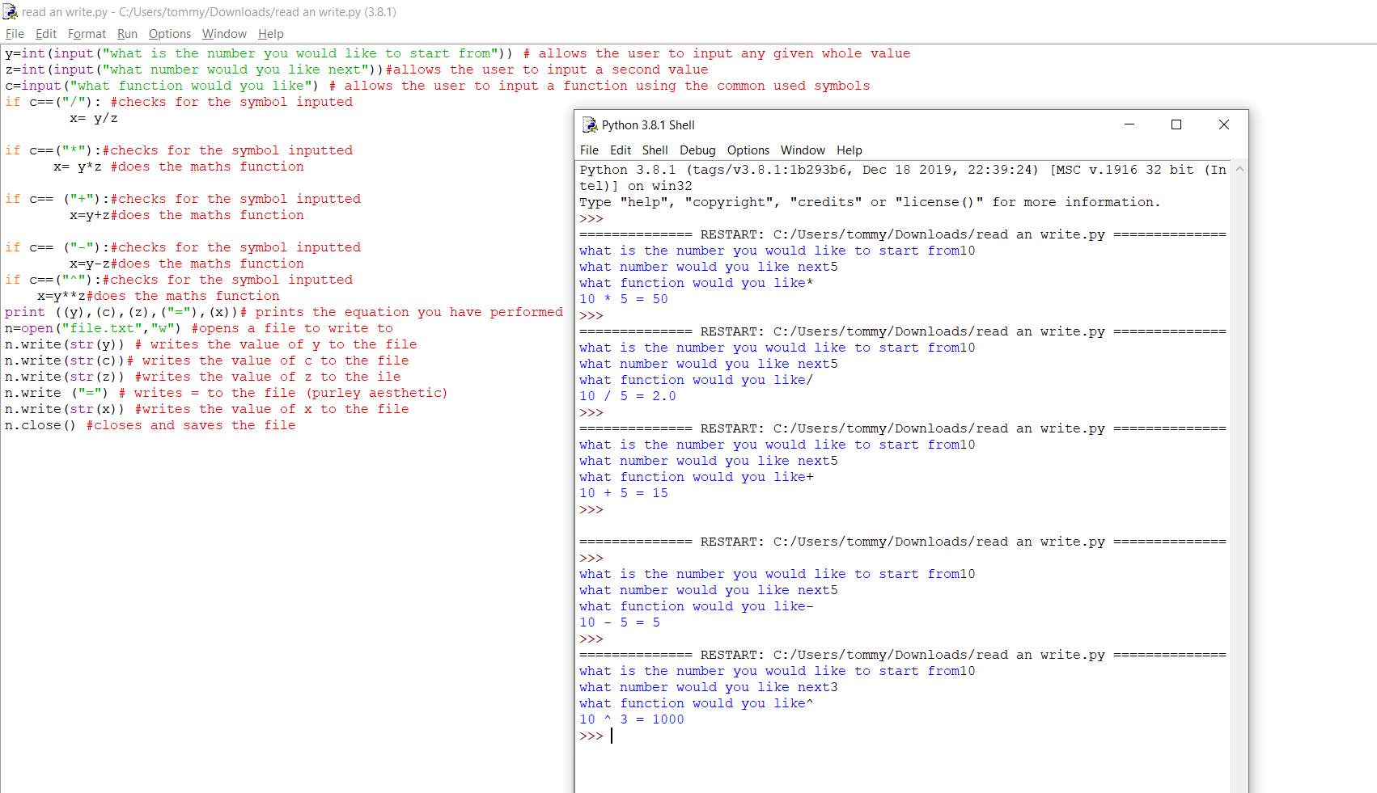

## Flowchart

## Pseudocode

Print what is the first number and wait for input

Save input as an integer

Print what is the next number and wait for input

Save input as integer

Print what function would you like

Save input as a variable

Checks the for the applicable function and applies the section of code

Takes the numbers and completes the math and saves as a string

Writes the equation an answer into a file.